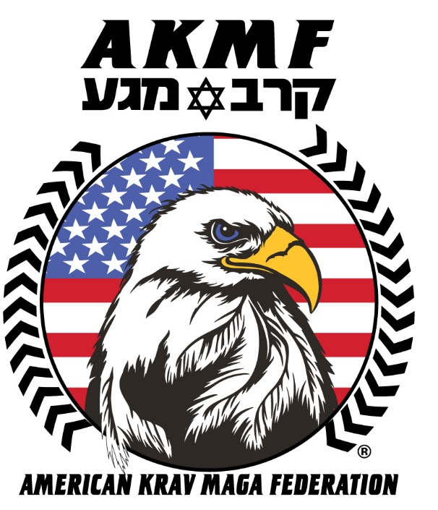
811 South Rogers Street, Pooler, Georgia
Phone: (912) 748-7111 WWW.AMERICANKRAVMAGAFEDERATION.COM

AFFILIATE AND
LICENCING PROGRAM

WELCOME
Dear Martial Art School Owner,
Thank you for your interest in the American Krav Maga Federation (AKMF) Affiliate and Licensing Program! Our goal is to provide school owners with real world Krav Maga Instruction as well as resources that will help your school grow. Upon reviewing the material in this brochure, you can request an application form, should you decide to take the next step in becoming an Official AKMF school.
Why Affiliate/Licensee?
The AKMF has established itself as an organization of excellence. Our instructors and staff are comprised of life long Martial Artists, Military and Law Enforcement Officers. We ruthlessly test all our techniques, not just in the classroom, but in real world environments, where only victory matters. Our organization has trained some of our nation’s best in the Special Operation (MIL) and Special Weapons and Tactics (LE) community. We take the feedback from those who use our craft in the most hostile of situations, dissect the techniques and ensure that the AKMF is armed with only what works when it matters most.
Program Advantages:
- AKMF represents decades of “end user testing” and continues to evolve based on the modern-day battlefield, requirements, and other necessities.
- Complements all other martial arts programs.
- Provides task specific skill sets and linkage of techniques to end user.
- Employable techniques in high stress environments.
- Standardization of crucial skills.
- Has been implemented within Conventional, Special Operation Military Forces and Law Enforcement with a high level of success.

AFFILIATE AND LICENSING PROGRAM
OVERVIEW
As a member of the AKMF Affiliate and Licensing Programs you will receive access to the following:
Realism based curriculum. As part of your membership, you gain access to the AKMFs best. With over 1,000 techniques, drills and strategies, your students can always expect dynamic, fun classes while learning high-level Krav Maga techniques.
- Realism based curriculum. We train only techniques that have been proven on the battlefield
- AKMF Authorized Student Manuals
- Instructional videos
- Liability Waivers
- Monthly Meeting with individual Affiliate Owners
- Leadership Development and best business practices to make your school successful
- Certificate format
- Logo design
- Personalized school merchandise
- Website domain name
- Website build and maintenance
- Tech Services and Training
- Marketing Material
- Pricing Structure
- Training Services
- Wholesale accounts
- Legal Documentation
- Monthly Leadership/business development

AFFILIATE PROGRAM
MEMBER BENEFITS
The following is a list of key benefits afforded to affiliate members:

Official Logo Use: Permission to use academy logo on school advertising and other promotional material such as business cards, letterheads, websites and school signage.

Listing on Official AKMF Website: Your school name will be listed on the official AKMF website. The website receives heavy traffic and will provide additional exposure for you and your school.

Monthly Affiliate and Licensee Meeting: As an AKMF Affiliate and Licensee you will be invited to a monthly meeting. This meeting is designed you build community within the AKMF affiliate and licensed school, discuss best practices, ask questions, and receive updates from the AKMF headquarters.

Unlimited training at AKMF headquarters or affiliate schools: To promote and encourage steady development, Affiliate owners have access to unlimited training at AKMF headquarters in Pooler Georgia.
Rank Promotion eligibility: All affiliate owners and their respective students become eligible for rank advancement through the program. Belt curriculum and rank guidelines will be provided. To rank other students, you must hold a minimum of a Green Belt ranking. All instructors must go through instructor training with AKMF Master Instructors at AKMF headquarters in Pooler, Ga. Or through our official AKMF mobile training team (AKMFMTT).

A fee of $5 will be paid for each student who test.

- Certificates for lower ranks 8.5”x11” (all student names and ranks must be summited 30 calendar days in advance)
- Certificate for Blackbelts 11’x17” (all student names and ranks must be summited 60 calendar days in advance)

AKMF Manuals: All Affiliate and Licensee owners will be able to purchase the official AKMF bound paper back manuals. This will ensure your program maintains a professional appearance while you focus on training your students.

Member Discounts: Affiliates receive discounted rates on AKMF seminars, workshops, and official merchandise.

- AKMF seminars and Workshops
- Quarterly T-Shirt Designs and Official merchandise
LICENSING PROGRAM
MEMBER BENEFITS
The following is a list of key benefits afforded to licensing members:

Official Logo Use: Permission to use AKMF logo on school advertising and other promotional material such as business cards, letterheads, websites, and school signage.

Listing on Official AKMF Website: As an AKMF Licensee your school’s name will be listed on the official AKMF Website. The website receives heavy traffic and will provide additional exposure for you and your school.

Liability Waivers: As an AKMF Licensee you will be granted access to our liability waiver templates. We have incurred the cost of having our lawyers craft up waivers to help protect you, your program and help reduce the burdens that inherently come as a business owner.

Website Development: As an AKMF Licensee our staff will help design, train, and maintain your website to help keep you focused on the mats while your online presence is securely maintained.

Monthly Affiliate and Licensee Meeting: As an AKMF Affiliate and Licensee you will be invited to a monthly meeting. This meeting is designed you build community within the AKMF affiliate and licensed school, discuss best practices, ask questions, and receive updates from the AKMF headquarters.

Monthly Leadership and Business development: As an AKMF Licensee you will receive monthly group discussions and 1 on 1 session via video teleconference to discuss individual issue, leader development, goal setting, project plaining etc.

Office Management: As an AKMF Licensee you will be presented with pricing structure, Marketing Material, staff reporting template and task organization charts to ensure your organization stays on top of the finer details that separate us from the competition.
Training Services: As an AKMF Licensee you will receive training services provided by AKMF related to the operation of a martial arts studio, including without limitation staff training and access to black belt instructors for testing and teaching.
Unlimited training at AKMF headquarters or affiliate schools: To promote and encourage steady development, Affiliate owners have access to unlimited training at AKMF headquarters in Pooler Georgia.
Rank Promotion eligibility: All affiliate owners and their respective students become eligible for rank advancement through the program. Belt curriculum and rank guidelines will be provided. To rank other students, you must hold a minimum of a Green Belt ranking. All instructors must go through instructor training with AKMF Master Instructors at AKMF headquarters in Pooler, Ga. Or through our official AKMF mobile training team (AKMFMTT).

A fee of $5 will be paid for each student who test.

- Certificates for lower ranks 8.5”x11” (all student names and ranks must be summited 30 calendar days in advance)
- Certificate for Blackbelts 11’x17” (all student names and ranks must be summited 60 calendar days in advance)

AKMF Manuals: All affiliate and licensee owners will be able to purchase the official AKMF bound paper back manuals. This will ensure your program maintains a professional appearance while you focus on training your students.

AKMF Founders Plaque: The first 10 licensed schools will receive an AKMF founders wall plaque, AKMF Banner and entrance door decal.

Member Discounts: Affiliates receive discounted rates on AKMF seminars, workshops, and official merchandise.

- AKMF seminars
- Workshops
- Official merchandise
- Quarterly T-Shirt Designs
- Full List of approved vendors

AFFILIATE AND LICENSING PROGRAM
MEMBERSHIP REQUIREMENTS
To be considered for inclusion as an affiliate of AKMF, the following requirements must be met and maintained:
Martial Arts Experience
Applicants must have a basic knowledge of Martial Arts, both in application and instruction. Qualify as an AKMF Instructor through the AKMF instructor development and qualification course.
Insurance
You must provide proof of liability insurance for your school. The minimum coverage shall be no less than two million dollars ($2,000,000.00)
Location
You must be no less than a 30-minute commute from any neighboring AKMF affiliate.
References
Four (4) character references with current contact information. The references cannot be family members.
Background Check
A thorough background check is required.

AFFILIATE AND LICENSING PROGRAM
MEMBERSHIP FEES
AKMF Affiliate memberships are based on a five-year agreement. Fees consists of the following:

FIVE YEAR AFFILIATE AGREEMENT:
Monthly Fee. No later than the fifth (5th) day of each calendar month during the Term, Licensee shall pay or cause to be paid to the American Krav Maga Federation a monthly fee of $300. Any overdue payment of thirty (30) days or more may be subject to costs of collection (including reasonable legal fees) and shall bear interest at the rate of two percent (2%) per month or fraction thereof until paid.
AKMF Licensing memberships are based on a five-year agreement.
Fees consists of the following:

FIVE YEAR AGREEMENT:
Monthly Fee. No later than the fifth (5th) day of each calendar month during the Term, Licensee shall pay or cause to be paid to the American Krav Maga Federation a monthly fee of $1,000. Any overdue payment of thirty (30) days or more may be subject to costs of collection (including reasonable legal fees) and shall bear interest at the rate of two percent (2%) per month or fraction thereof until paid.

LEGACY LICENSING AGREEMENT:
Legacy licensing is a One Time Licensing Fee. This one-time fee eliminates any future monthly or annual fees for the Legacy of your school. Within ten (10) days of the Effective Date, Licensee shall pay or cause to be paid to Pooler Karate an up-front, onetime fee of $50,000.

Fee Collection: All monthly Affiliate and Licensing agreement fees will be collected through electronic funds transfer unless representatives choose to pay annual fees in full. All annual in full payments will receive a 15% rate reduction for the coverage period.

- Affiliate annual paid in full. $3600- 15% = $3060 ($540 savings)

- Licensee annual paid in full. $12,000-15%=$10,200 ($1800 savings)

- Legacy Licensing onetime fee $50,000 (10 Years of Licensing = $120,000 - one-time fee =$70,000 savings)

AFFILIATE AND LICENSING PROGRAM
SEMINAR/PRIVATE TRAINING FEES
The AKMF maintains strict requirements for rank advancement.
The AKMF requires a minimum of 2 seminars a year and provides the opportunities for your instructors and students to book private training sessions while AKMF Head Quarters Master Instructors are in town.
Seminars are not only a fantastic opportunity for personal interaction with our Master Instructors, but they also help maintain high standards within your school, encourage student retention, validate your belt promotions, and offer a memorable, motivating experience for your students who receive rank advancement from both you and AKMF.
AMERICAIN KRAV MAGA FEDERATION SEMINAR AND TRAINING FEES:
The following are affiliate and licensee seminar and training fees:
- Private training sessions at your location.
- Individual $150 per hour ($250 for non-licensed schools)
- Group $600.00 2-hour session ($1,000 for non-licensed schools)
- Plus, travel and local per diem rates.

- Seminar 2-hour session - $1,500.00 ($2,500 for non-licensed schools)

- Instructor Continuing education
- Travel Expenses and local per diem rates are required for travel beyond sixty (60) miles.

AMERICAN KRAV MAGA FEDERATION
AFFILIATE AND LICENSING APPLICATION
Personal Information
__________________________ _______________________ __________________ ____
Last First Middle Suffix
__________________________ _______________________ _____________ _________
Address City State/Province Postal Code
__________________________ _______________________ ________________________
Cell Phone Office Phone Email Address
Are you a US Citizen [] Yes [] No

Have you ever been convicted of a felony [] Yes [] No (if yes explain):

Education and Training
School/Course Name | Location | Degree/Certification | Major
Business/School Information
____________________________________________________________ ______________
Business/School Name Year Established
__________________________ _______________________ _____________ _________
Address City State/Province Postal Code
__________________________ ________________________________________________
Website Facility Size Sqft

Other Affiliations: 1)
2)
3)
4)
May we contact them [] Yes [] No
References
Name | Title | Company | Contact Number
ex. John Doe | Owner/Master Instructor | America’s Best Krav Maga | (803)-123-4567
Acknowledgement and Authorization
_____ I certify that all answers given herein are true and complete to the best of my knowledge.
_____ I authorize investigation of all statements contained in this application for affiliation as may be necessary in arriving at an affiliate decision.
_____ In the event of affiliation, I understand that false or misleading information given in my application or interview(s) may result in discharge.
AKMF PROGRAMS
I ____________________ agree to the above terms and select to request to be part of the following program.
(First, MI, Last, Suffix)

- 5 Year AKMF Affiliation Program

- 5 Year AKMF Licensing Program

- Legacy Licensing Program

Signature: _______________________________________________________ Date: __________________

Witness Signature: ________________________________________________ Date: __________________

